PRINCIPLES OF LINUX
OPERATING SYSTEMS
COMPLETE UBUNTU PRACTICAL ASSIGNMENT
Chapters 1–4 | Commands • Explanations • Examples • Screenshot Evidence • Exam Review

Student name: Farhia Hassan Mohamud
Student ID: C6240033
Department / Class: CNS241
Lecturer: Teacher Nasri
Submission date: 12/Nov/2026

Jamhuriya University of Science and Technology
Faculty of Computer and Information Technology

How to use this assignment
This document organizes the four Linux chapters shared for the course. It uses simple English and gives the main ideas, terminal commands, practical examples, expected results, screenshot spaces, and revision questions.
- Open your Ubuntu virtual machine and open Terminal with Ctrl + Alt + T.
- Type commands one at a time. Press Enter after each command.
- Your computer may show different usernames, dates, process IDs, disk sizes, and output. That is normal.
- Take your own screenshots after running the practical work, then insert them in the marked spaces.
- Save this Word file before uploading it to your GitHub repository and submitting it to McLink.

Table of contents
- Chapter 1 — Introduction to Linux and Ubuntu
- Chapter 2 — Linux System Architecture, Command Line, and File Management
- Chapter 3 — Text Processing, Searching, Archiving, and Editors
- Chapter 4 — Process, Service, and System Management
- Final checklist — Screenshots, GitHub, and submission

CHAPTER 1 — INTRODUCTION TO LINUX AND UBUNTU
Learning goal: understand operating systems, Linux, the kernel, distributions, Ubuntu, and the first terminal commands.

1.1 What is an Operating System?
An Operating System (OS) is the main software that manages computer hardware and allows users and applications to work with the computer. It acts as a bridge between the user, programs, and hardware.

Main functions of an OS
- CPU management: shares processor time between running programs.
- Memory management: controls how RAM is used by programs.
- File management: organizes files and folders and controls access.
- Device management: communicates with devices through drivers.
- User interface: provides a graphical desktop or a command-line terminal.

1.2 What is Linux?
Linux is strictly the kernel: the core part of an operating system that communicates with hardware and manages resources. In everyday language, people also use “Linux” to mean a complete operating system built around the Linux kernel.

Kernel, distribution, and desktop
- Kernel: the core that manages hardware, memory, processes, files, and networking.
- Distribution (distro): a complete system containing the Linux kernel, tools, applications, and an installer. Examples: Ubuntu, Debian, Fedora, Linux Mint.
- Desktop environment: the graphical interface with windows, icons, menus, and panels. Ubuntu Desktop commonly uses GNOME.

1.3 Short history of Linux
- Unix ideas developed at Bell Labs in the 1960s–1970s.
- The GNU Project began in 1983 and developed free software tools.
- Linus Torvalds began the Linux kernel in 1991.
- Debian was launched in 1993.
- Ubuntu, based on Debian, was first released in 2004.

1.4 Linux kernel and system architecture
The kernel sits between applications and hardware. It manages processes, memory, files, networking, and security. Applications request services from the operating system instead of controlling hardware directly.

1.5 Linux distributions and families
- Debian family: Debian, Ubuntu, Linux Mint.
- Red Hat family: Red Hat Enterprise Linux, Fedora, Rocky Linux.
- SUSE family: SUSE Linux Enterprise and openSUSE.
- Arch family: Arch Linux and related distributions.

1.6 Ubuntu Linux
Ubuntu is a Linux distribution based on Debian. Ubuntu Desktop is designed for personal computers and includes a graphical desktop. Ubuntu Server is designed for server workloads and commonly runs without a graphical desktop. LTS means Long-Term Support.

1.7 Why Linux matters
Linux is widely used on servers, cloud platforms, supercomputers, networking equipment, and embedded devices. It is flexible, widely supported, and its source code is available under open-source licences.

1.8 Linux, Windows, and macOS
Windows, macOS, and Linux are operating systems. They all manage hardware and run applications, but they differ in design, licensing, software availability, and the way users manage the system.

1.9 Free and Open-Source Software (FOSS)
Free and Open-Source Software gives users freedoms to run, study, modify, and share software under its licence. Examples of licences include GNU GPL, MIT, BSD, and Apache. “Free” refers to freedom, not always to zero price.

1.10 First Ubuntu terminal commands
whoami — whoami
Displays the username of the currently logged-in user.
whoami
farhia

pwd — pwd
Prints the current working directory.
pwd
/home/farhia

uname -r — uname -r
Displays the version of the running Linux kernel.
uname -r
6.x.x-generic (example; your version may differ)

cat /etc/os-release — cat /etc/os-release
Displays information about the installed Linux distribution.
cat /etc/os-release
NAME="Ubuntu"
VERSION="..." (your version may differ)

Chapter 1 practical
whoami
pwd
uname -r
cat /etc/os-release

Practical screenshot evidence
Run the practical commands in your own Ubuntu VM. Take a clear screenshot showing the terminal prompt, commands, and output. Insert your own screenshot below for Chapter 1. Do not use lecture sample screenshots as your own evidence.

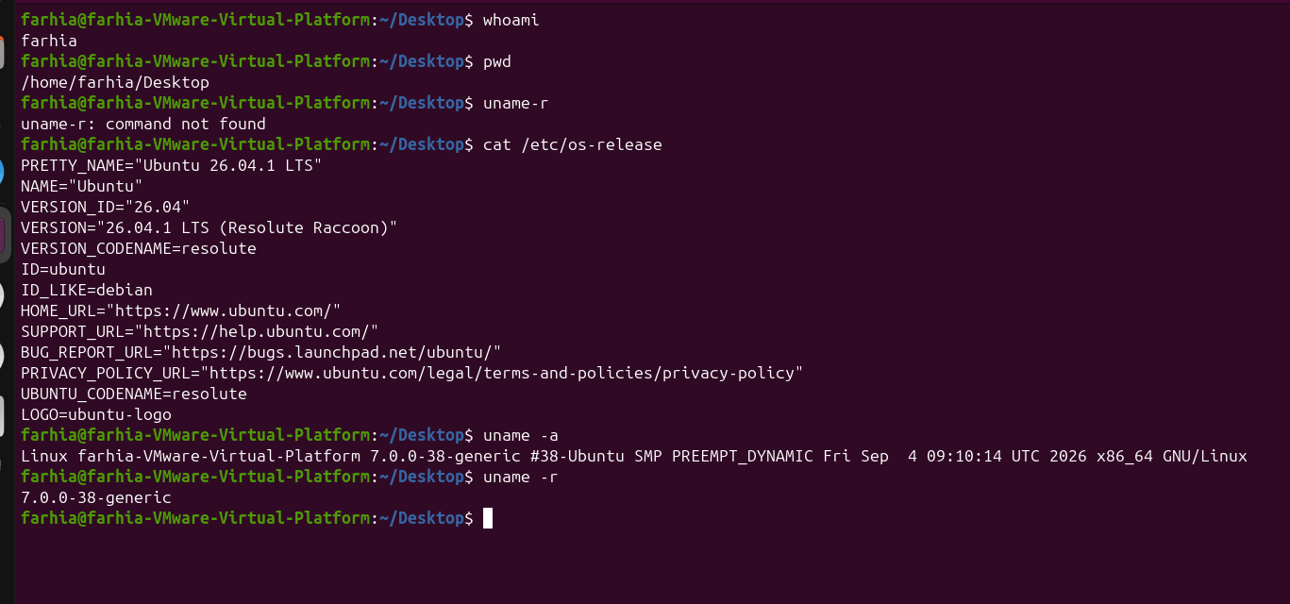

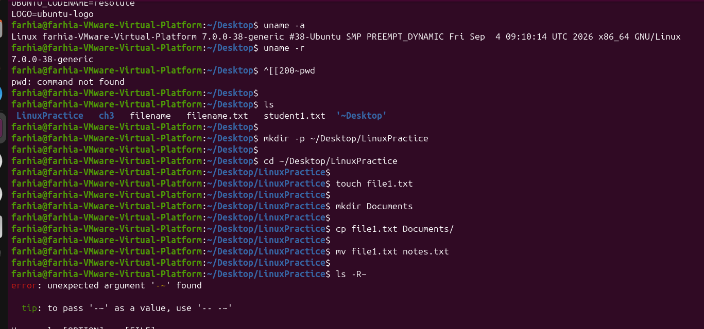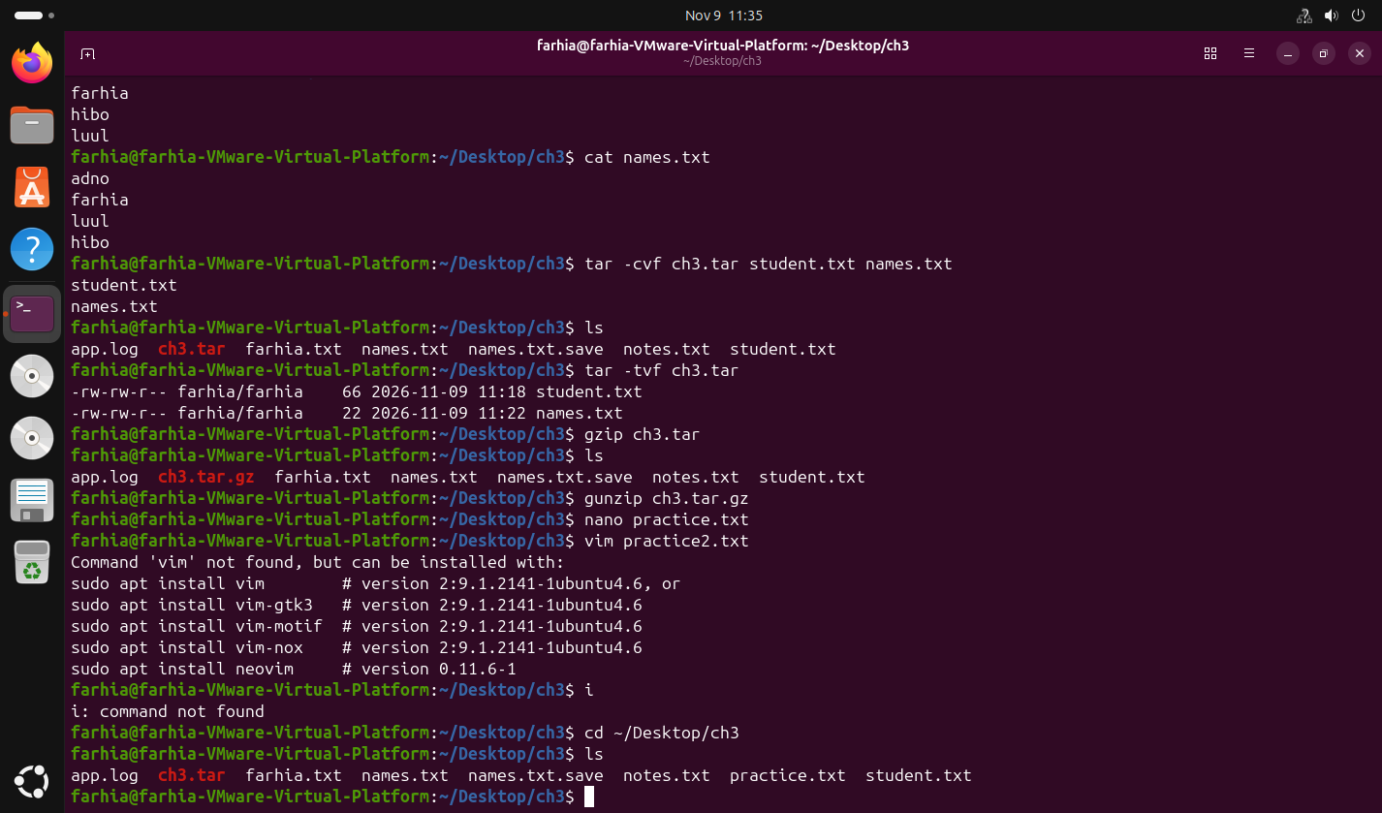

Exam revision: questions and answers
Q: What is an operating system?
A: It is the main software that manages computer hardware and allows applications to run.
Q: What is the Linux kernel?
A: It is the core of Linux that manages hardware and system resources.
Q: What is a Linux distribution?
A: A complete system built around the Linux kernel, with tools and applications.
Q: Who began the Linux kernel?
A: Linus Torvalds began it in 1991.
Q: What does LTS mean?
A: Long-Term Support.

CHAPTER 2 — LINUX SYSTEM ARCHITECTURE, COMMAND LINE, AND FILE MANAGEMENT
Learning goal: understand the Linux filesystem and Bash, get command help, use variables and paths, and manage files safely.

2.1 Linux system architecture and filesystem
Linux organizes files and directories in one tree that starts at the root directory, written as /. Important directories include:
- / — the top of the filesystem tree.
- /home — personal directories for ordinary users.
- /etc — system-wide configuration files.
- /var — changing data such as logs and caches.
- /usr — many installed programs, libraries, and shared data.
- /tmp — temporary files.
- /boot — files needed to start the system.
- /dev — device files.
- /proc — virtual information about processes and the kernel.
- /sys — virtual information about devices and the kernel.

2.2 The terminal and Bash
A terminal is an application where a user types commands. Bash is a command-line shell that reads the commands and runs programs. A command usually contains a command name, options, and arguments.

2.3 Getting help and command history
man — man COMMAND
Opens the manual page for a command. Press q to quit.
man ls
Manual page for ls opens.

--help — COMMAND --help
Shows a short help page for a command.
ls --help
Displays available options for ls.

info — info COMMAND
Opens the Info documentation when available.
info coreutils
Opens Coreutils documentation.

history — history
Displays commands previously entered in the current shell.
history
1 pwd
2 ls
3 history

type — type COMMAND
Explains how Bash interprets a command name.
type cd
cd is a shell builtin

command -v — command -v COMMAND
Shows the path of an executable or identifies a shell command.
command -v ls
/usr/bin/ls

2.4 Quoting, escaping, and wildcards
- Single quotes ('...') preserve the characters literally.
- Double quotes ("...") allow variable expansion but protect spaces.
- Backslash (\) can escape a special character.
- * matches zero or more characters; ? matches one character.
- Tab completion helps complete filenames and command names.
echo 'Linux basics'
echo "My home is $HOME"
ls *.txt
ls file?.txt

2.5 Variables, PATH, and export
A shell variable stores a value. PATH is an environment variable containing directories where the shell looks for executable programs. The export command makes a variable available to programs launched from the current shell. This normally lasts for the current session.
Create a variable — NAME=value
There must be no spaces around the equals sign.
COURSE=Linux

Read a variable — echo $NAME
The dollar sign asks the shell to display the variable's value.
echo $COURSE
Linux

Export a variable — export NAME=value
Makes the variable available in the environment of child programs.
export COURSE=Linux
printenv COURSE
Linux

Export a value with spaces — export COURSE="Linux basics"
Use quotation marks when the value contains spaces.
export COURSE="Linux basics"
printenv COURSE
Linux basics

Show exported variables — export -p
Lists variables that have been exported.
export -p
A list of exported variables, including COURSE if it is exported.

Show PATH — echo $PATH
Displays directories searched for commands.
echo $PATH
/usr/local/sbin:/usr/local/bin:/usr/sbin:/usr/bin:...

Locate Bash startup file — ls -a ~
Shows hidden files in the home directory, including .bashrc if present.
ls -a ~
..., .bashrc, ...

2.6 Paths, navigation, and filenames
pwd — pwd
Shows the current directory.
pwd
/home/farhia

cd — cd DIRECTORY
Changes the current directory.
cd /etc
pwd
/etc

cd .. — cd ..
Moves one directory level up.
cd ..

cd ~ — cd ~
Moves to the current user's home directory.
cd ~

ls — ls
Lists files and directories.
ls

ls -l — ls -l
Shows a detailed listing including permissions and file sizes.
ls -l

ls -a — ls -a
Shows hidden files as well as normal files.
ls -a

2.7 Creating and managing files
mkdir — mkdir DIRECTORY
Creates a directory.
mkdir practice

mkdir -p — mkdir -p parent/child
Creates parent directories as needed.
mkdir -p practice/week1/notes

touch — touch FILE
Creates an empty file if it does not exist, or updates its timestamp.
touch notes.txt

cp — cp SOURCE DESTINATION
Copies a file.
cp notes.txt notes-copy.txt

cp -r — cp -r SOURCE_DIR DEST_DIR
Copies a directory and its contents recursively.
cp -r practice practice-backup

mv — mv SOURCE DESTINATION
Moves or renames a file or directory.
mv notes-copy.txt renamed-notes.txt

rm -i — rm -i FILE
Asks for confirmation before removing a file. Check the filename carefully.
rm -i old-notes.txt
Prompts before removing the file.

rmdir — rmdir DIRECTORY
Removes an empty directory.
rmdir empty-folder

Chapter 2 practical exercise
The following practice creates a small folder and files in your home directory:
cd ~
mkdir -p LinuxPractice/Chapter2
cd LinuxPractice/Chapter2
touch notes.txt
printf 'Linux practice\n' > notes.txt
cat notes.txt
cp notes.txt notes-copy.txt
mv notes-copy.txt final-notes.txt
ls -l
export COURSE=Linux
printenv COURSE
export -p

Expected result: a folder named LinuxPractice/Chapter2 containing notes.txt and final-notes.txt. The exported COURSE variable should display Linux.

Practical screenshot evidence
Run the practical commands in your own Ubuntu VM. Take a clear screenshot showing the terminal prompt, commands, and output. Insert your own screenshot below for Chapter 2. Do not use lectu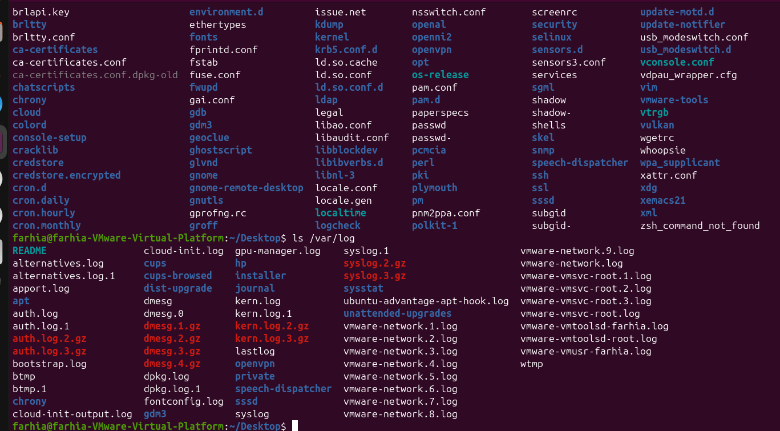re sample screenshots as your own evidence.
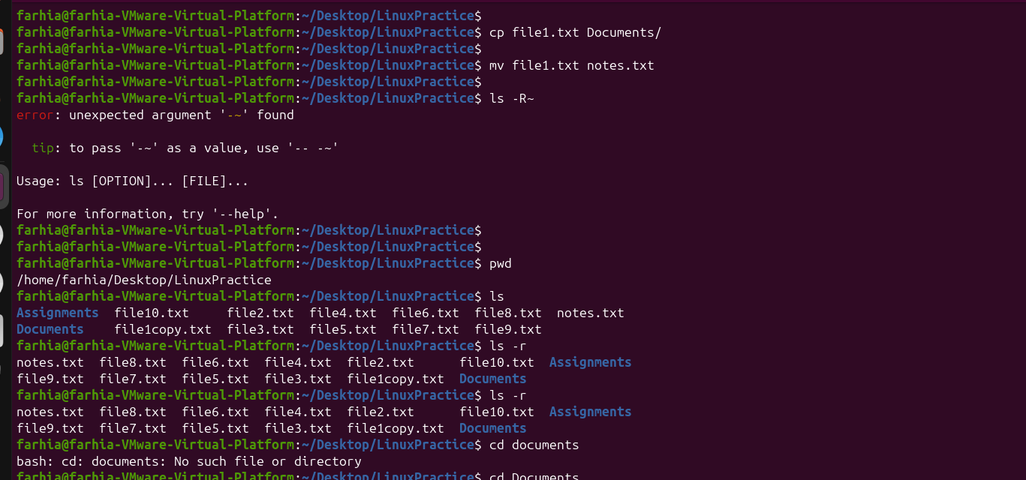

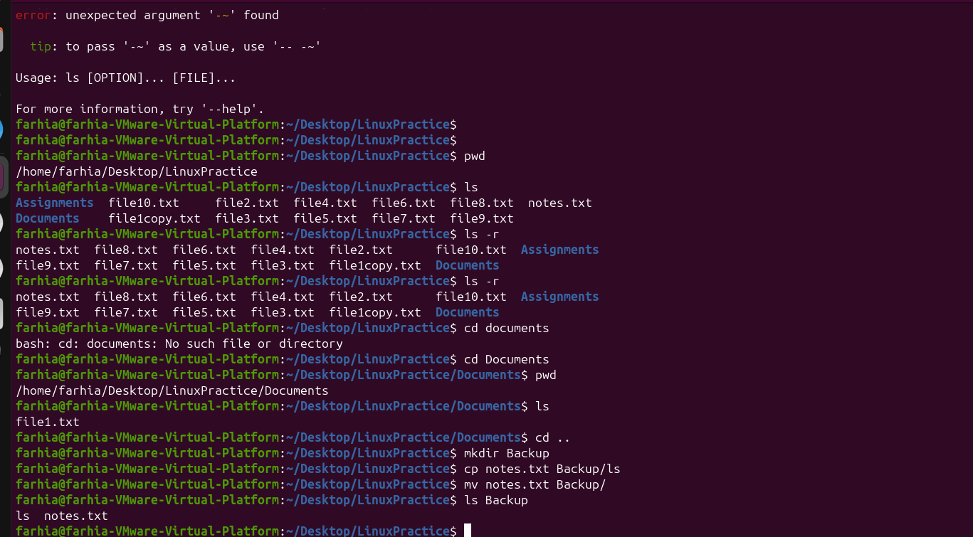
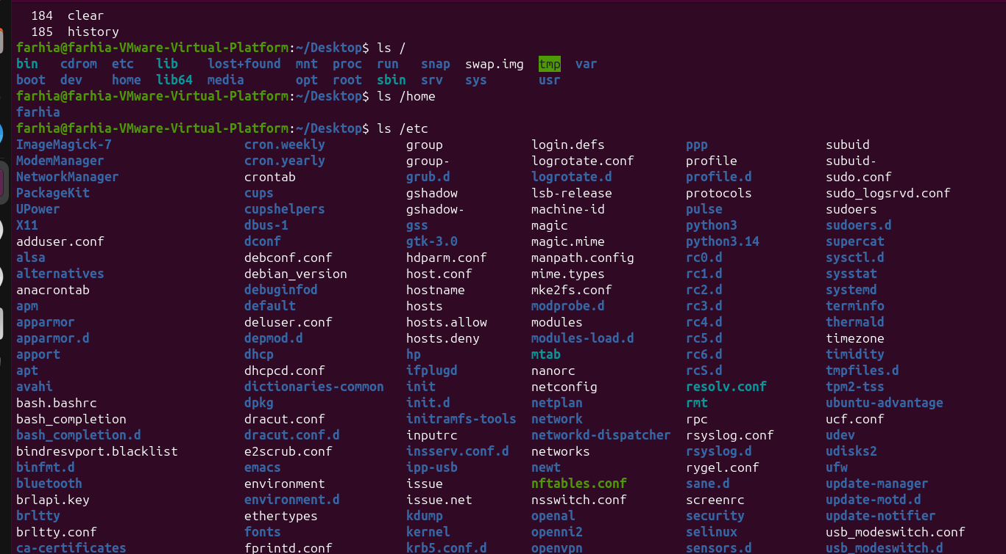
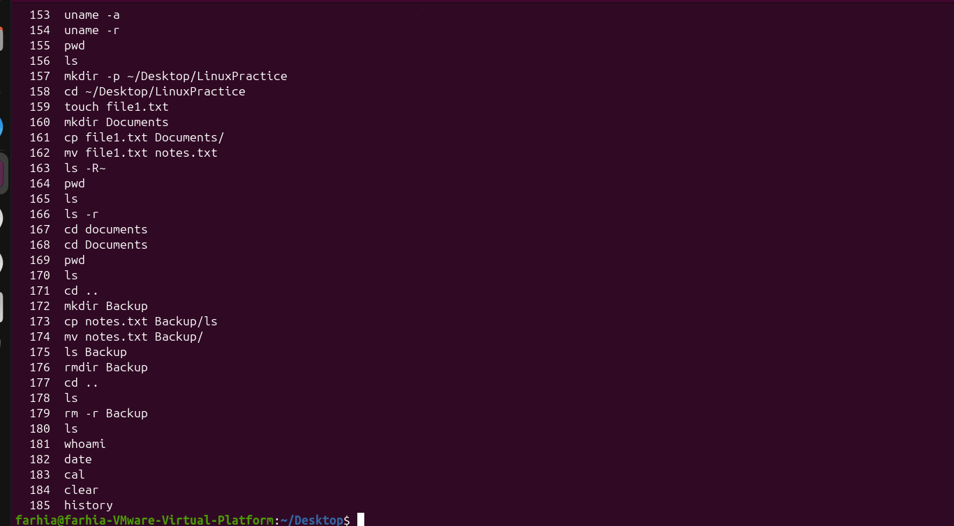

Exam revision: questions and answers
Q: What does pwd do?
A: It prints the current working directory.
Q: What is the difference between an absolute and relative path?
A: An absolute path starts from /; a relative path starts from the current directory.
Q: What does mkdir -p do?
A: It creates parent directories when needed.
Q: What does cp do?
A: It copies files or directories when used with the appropriate option.
Q: What does export do?
A: It makes a shell variable available to child processes.
Q: What is PATH?
A: It is a list of directories searched by the shell for executable commands.

CHAPTER 3 — TEXT PROCESSING, SEARCHING, ARCHIVING, AND EDITORS
Learning goal: display, search, filter, count, transform, archive, compress, and edit text files.

3.1 Displaying and reading text
cat — cat FILE
Displays the contents of a text file.
cat names.txt
Ali
Hodan
Yusuf

less — less FILE
Reads a long file one screen at a time. Press q to quit.
less /etc/os-release
Opens the file in a pager.

head — head FILE
Displays the first 10 lines by default.
head names.txt

head -n — head -n 5 FILE
Displays the first five lines.
head -n 5 names.txt

tail — tail FILE
Displays the last 10 lines by default.
tail names.txt

tail -f — tail -f FILE
Follows new lines added to a file. Press Ctrl+C to stop.
tail -f app.log

3.2 Searching and filtering
grep — grep 'word' FILE
Searches for lines containing a matching word or pattern.
grep 'Linux' notes.txt

grep -i — grep -i 'word' FILE
Searches without matching letter case.
grep -i 'error' app.log

grep -n — grep -n 'word' FILE
Shows matching lines with line numbers.
grep -n 'Linux' notes.txt

find — find PATH -name 'PATTERN'
Searches for files and directories by name.
find ~ -name '*.txt'

sort — sort FILE
Sorts lines alphabetically by default.
sort names.txt

uniq — uniq FILE
Removes adjacent duplicate lines. Usually combine with sort first.
sort names.txt | uniq

wc — wc FILE
Counts lines, words, and bytes.
wc names.txt
3 3 15 names.txt (example; depends on file)

wc -l — wc -l FILE
Counts lines.
wc -l names.txt
3 names.txt

cut — cut -d':' -f1 FILE
Extracts a selected field using a delimiter.
cut -d: -f1 /etc/passwd

tr — tr 'a-z' 'A-Z'
Transforms characters from standard input.
printf 'linux\n' | tr 'a-z' 'A-Z'
LINUX

3.3 Pipes and redirection
A pipe (|) sends the output of one command to the input of another command. Redirection sends output or input to a file.
- > writes output to a file and replaces its previous contents.
- >> appends output to the end of a file.
- < reads input from a file.
- 2> sends error output to a file.
- && runs the next command only if the previous command succeeds.
- || runs the next command only if the previous command fails.
- ; runs commands one after another regardless of success.
printf 'First line\n' > actions.txt
printf 'Second line\n' >> actions.txt
cat actions.txt
grep -i 'error' app.log | wc -l
mkdir -p demo && echo 'Folder created'
test -f missing.txt || echo 'File not found'

3.4 Archives and compression
Archiving combines files into one archive. Compression reduces the amount of storage space. They are often used together, but they are not the same operation.
tar -cf — tar -cf archive.tar DIRECTORY
Creates an uncompressed tar archive.
tar -cf backup.tar LinuxPractice

tar -tf — tar -tf archive.tar
Lists the contents of an archive without extracting it.
tar -tf backup.tar

tar -xf — tar -xf archive.tar
Extracts a tar archive into the current directory.
tar -xf backup.tar

tar -czf — tar -czf archive.tar.gz DIRECTORY
Creates a gzip-compressed tar archive.
tar -czf backup.tar.gz LinuxPractice

tar -xzf — tar -xzf archive.tar.gz
Extracts a gzip-compressed tar archive.
tar -xzf backup.tar.gz

gzip — gzip FILE
Compresses a file and normally replaces it with a .gz file.
gzip notes.txt

gunzip — gunzip FILE.gz
Decompresses a gzip file.
gunzip notes.txt.gz

bzip2 / bunzip2 — bzip2 FILE | bunzip2 FILE.bz2
Compresses or decompresses using bzip2.
bzip2 notes.txt
bunzip2 notes.txt.bz2

xz / unxz — xz FILE | unxz FILE.xz
Compresses or decompresses using xz.
xz notes.txt
unxz notes.txt.xz

zip — zip archive.zip FILE
Creates a ZIP archive.
zip notes.zip notes.txt

unzip — unzip archive.zip
Extracts a ZIP archive.
unzip notes.zip

3.5 Text editors: nano and vim

Nano
Nano is a beginner-friendly terminal text editor. The shortcut list is usually shown at the bottom of the screen.
nano notes.txt
# Type your text
# Ctrl + O = write/save
# Enter = confirm filename
# Ctrl + X = exit

Vim
Vim is a modal text editor. It has different modes for entering text and running editor commands.
vim notes.txt
# i = enter Insert mode
# Type your text
# Esc = return to Normal mode
# :w = save
# :q = quit
# :wq = save and quit
# :q! = quit without saving changes

3.6 Links: hard links and symbolic links
ln — ln SOURCE HARDLINK
Creates a hard link: another filename for the same file data (same inode).
ln notes.txt notes-hard.txt

ln -s — ln -s TARGET SYMLINK
Creates a symbolic link that stores a path to the target.
ln -s notes.txt notes-shortcut.txt

ls -li — ls -li FILE1 FILE2
Displays inode numbers, useful for comparing hard links.
ls -li notes.txt notes-hard.txt

Chapter 3 practical exercise
mkdir -p ~/LinuxPractice/Chapter3
cd ~/LinuxPractice/Chapter3
printf 'Ali\nHodan\nYusuf\nAli\n' > names.txt
cat names.txt
grep -i 'ali' names.txt
sort names.txt | uniq -c
wc -l names.txt
cut -d: -f1 /etc/passwd | head -n 5
tr 'a-z' 'A-Z' < names.txt
tar -czf names-backup.tar.gz names.txt
tar -tf names-backup.tar.gz
nano notes.txt

Expected result: names.txt contains four lines; the search finds Ali; sort and uniq count repeated names; the tar command creates a compressed archive.

Practical screenshot evidence
Run the practical commands in your own Ubuntu VM. Take a clear screenshot showing the terminal prompt, commands, and output. Insert your own screenshot below for Chapter 3. Do not use lecture sample screenshots as your own evidence.
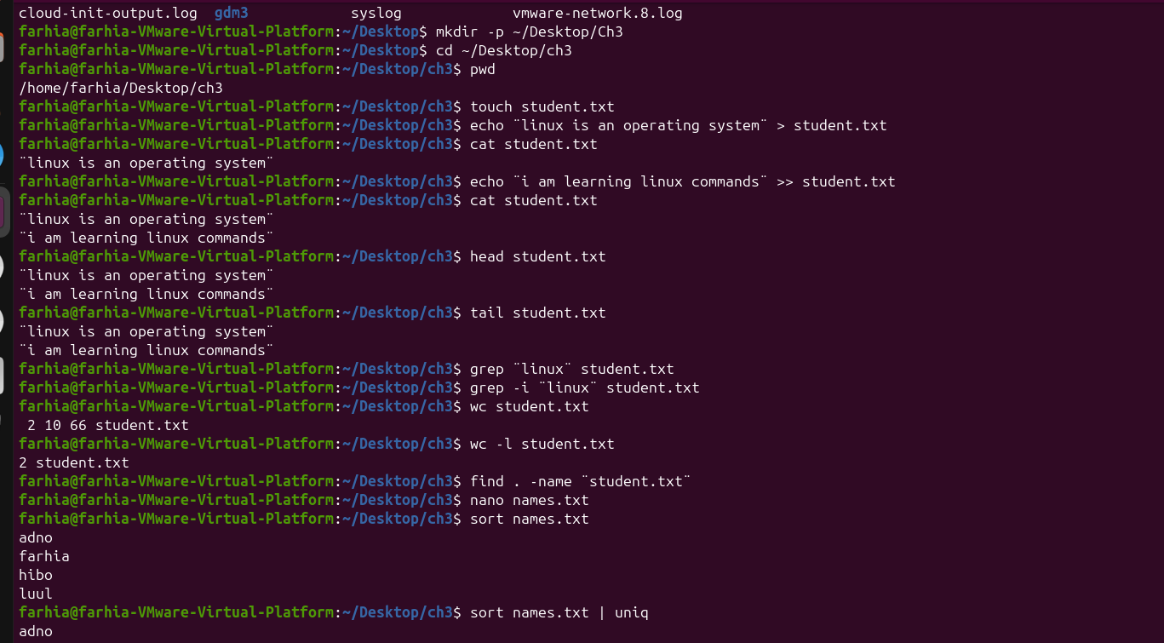
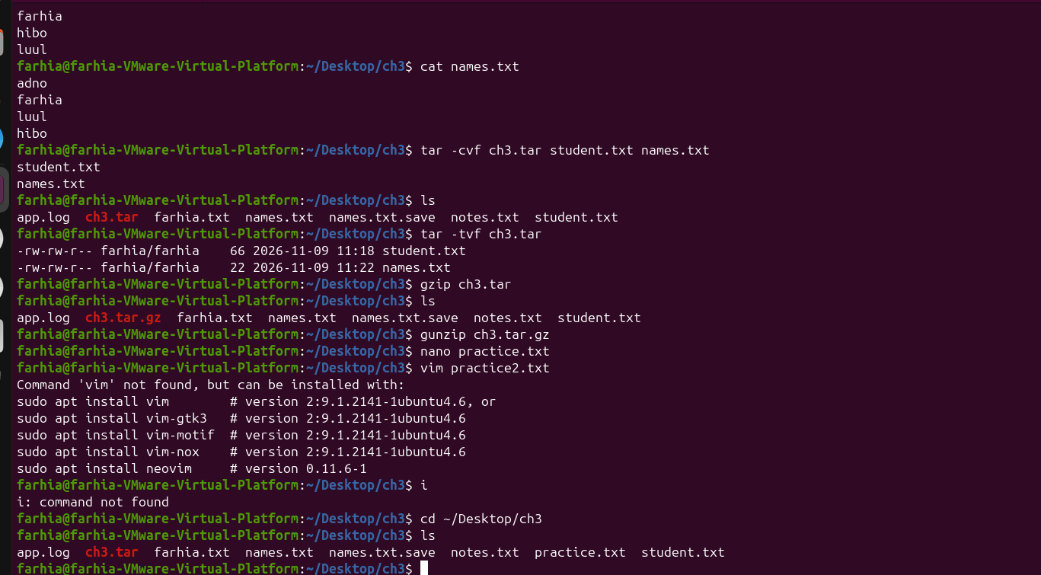

Exam revision: questions and answers
Q: What does grep do?
A: It searches text for matching lines.
Q: What does wc -l do?
A: It counts the number of lines.
Q: What is a pipe?
A: It sends the output of one command to another command.
Q: What is the difference between > and >>?
A: > replaces file contents; >> appends to the file.
Q: What is the difference between archiving and compression?
A: Archiving groups files; compression reduces file size.
Q: How do you save and exit Nano?
A: Ctrl+O, Enter, then Ctrl+X.
Q: How do you save and quit Vim?
A: Press Esc, type :wq, and press Enter.

CHAPTER 4 — PROCESS, SERVICE, AND SYSTEM MANAGEMENT
Learning goal: inspect processes, manage foreground/background jobs, send signals, view system information, manage services, and read logs.

4.1 Processes and jobs
A process is a running program. Each process has a Process ID (PID). The Parent Process ID (PPID) identifies the process that started it.
echo $$ — echo $$
Displays the PID of the current shell.
echo $$
A number such as 2318 (varies).

ps — ps
Displays processes associated with the current terminal.
ps

ps -f — ps -f
Displays a fuller process listing, including PPID and start information.
ps -f

ps aux — ps aux
Displays processes from all users with CPU and memory information.
ps aux | head

ps -ef — ps -ef
Displays all processes in full-format style.
ps -ef | head

ps -p — ps -p PID -o pid,user,comm
Displays information about one process.
ps -p 1 -o pid,user,comm
PID USER COMMAND
1 root systemd

top — top
Shows a live, updating view of processes and resource usage. Press q to quit.
top

htop — htop
A more interactive process viewer, if installed. Use top if htop is unavailable.
command -v htop

pstree — pstree -p
Displays processes in a tree, showing parent-child relationships.
pstree -p

Foreground and background jobs
sleep 30
# Waits in the foreground for 30 seconds
sleep 30 &
# Runs in the background; the prompt returns
jobs -l
# Lists jobs started from this terminal
fg %1
# Brings job 1 to the foreground
bg %1
# Resumes job 1 in the background

Ctrl+C interrupts the foreground command. Ctrl+Z pauses the foreground command and returns the prompt. Use jobs to see stopped/background jobs.

4.2 Signals and process priority
kill — kill PID
Sends SIGTERM by default, asking a process to finish cleanly.
sleep 300 &
# Note the PID printed by the shell
kill PID

kill -TERM — kill -TERM PID
Explicitly sends the polite termination signal.
kill -TERM PID

kill -9 — kill -9 PID
Sends SIGKILL. Use only as a last resort because the process cannot clean up.
kill -9 PID

killall — killall PROCESS_NAME
Sends a signal to processes matching a name. Check the name carefully.
killall sleep

pkill — pkill PROCESS_NAME
Selects processes by name or pattern and sends a signal.
pkill sleep

kill -l — kill -l
Lists available signals.
kill -l

nice — nice -n VALUE COMMAND
Starts a command with a chosen niceness value. Higher niceness means lower scheduling priority.
nice -n 10 sleep 60 &

renice — renice VALUE -p PID
Changes the niceness value of an existing process, subject to permissions.
renice 10 -p PID

Important: try SIGTERM first. SIGKILL (signal 9) is a last resort. Always check the PID before sending a signal.

4.3 System information
uname -a — uname -a
Displays kernel and system information.
uname -a

hostnamectl — hostnamectl
Displays or manages the system hostname and related information.
hostnamectl

uptime — uptime
Shows how long the system has been running and the load average.
uptime

uptime -p — uptime -p
Shows uptime in a human-readable format.
uptime -p
up 2 hours, 41 minutes (example)

free -h — free -h
Displays memory and swap usage in readable units.
free -h

lscpu — lscpu
Displays CPU architecture and processor details.
lscpu

lsblk — lsblk
Lists block devices such as disks and partitions.
lsblk

/proc — cat /proc/cpuinfo
Shows kernel-provided information about the CPU.
head /proc/cpuinfo

/sys — ls /sys
Shows the virtual sysfs tree for devices and kernel information.
ls /sys

4.4 Services with systemd
A service is a background program that provides a system function. systemctl is used to inspect and manage systemd services.
systemctl status — systemctl status SERVICE
Shows the current state and recent information for a service.
systemctl status cron

systemctl is-active — systemctl is-active SERVICE
Prints whether a service is active.
systemctl is-active cron
active (if the service is running)

systemctl start — sudo systemctl start SERVICE
Starts a service now. Administrator permission may be required.
sudo systemctl start cron

systemctl stop — sudo systemctl stop SERVICE
Stops a service now. Only use this when you understand the effect.
sudo systemctl stop cron

systemctl restart — sudo systemctl restart SERVICE
Stops and starts a service again.
sudo systemctl restart cron

systemctl enable — sudo systemctl enable SERVICE
Configures a service to start automatically at boot.
sudo systemctl enable cron

systemctl disable — sudo systemctl disable SERVICE
Removes automatic startup at boot; it does not necessarily stop a running service.
sudo systemctl disable cron

4.5 Logs and troubleshooting
journalctl — journalctl
Displays the systemd journal.
journalctl -n 20

journalctl -u — journalctl -u SERVICE
Shows journal entries for a particular service.
journalctl -u cron -n 20

journalctl -b — journalctl -b
Shows messages from the current boot.
journalctl -b -n 30

dmesg — dmesg
Displays kernel ring-buffer messages, often useful for device troubleshooting.
dmesg | tail

/var/log — ls /var/log
Lists system log files stored under /var/log.
ls /var/log

4.6 Safe shutdown
shutdown — sudo shutdown now
Shuts down the computer now. Save your work first.
sudo shutdown now

reboot — sudo reboot
Restarts the computer. Save your work first.
sudo reboot

Chapter 4 practical exercise
echo $$
ps -o pid,ppid,comm
ps aux | head -n 10
uptime -p
free -h
lscpu
lsblk
systemctl is-active cron
journalctl -u cron -n 10
dmesg | tail

Expected result: the terminal displays your shell PID, process information, system uptime, memory, CPU and disk information, service state, and recent log messages. Some log commands may require sudo on your Ubuntu system.

Practical screenshot evidence
Run the practical commands in your own Ubuntu VM. Take a clear screenshot showing the terminal prompt, commands, and output. Insert your own screenshot below for Chapter 4. Do not use lecture sample screenshots as your own evidence.
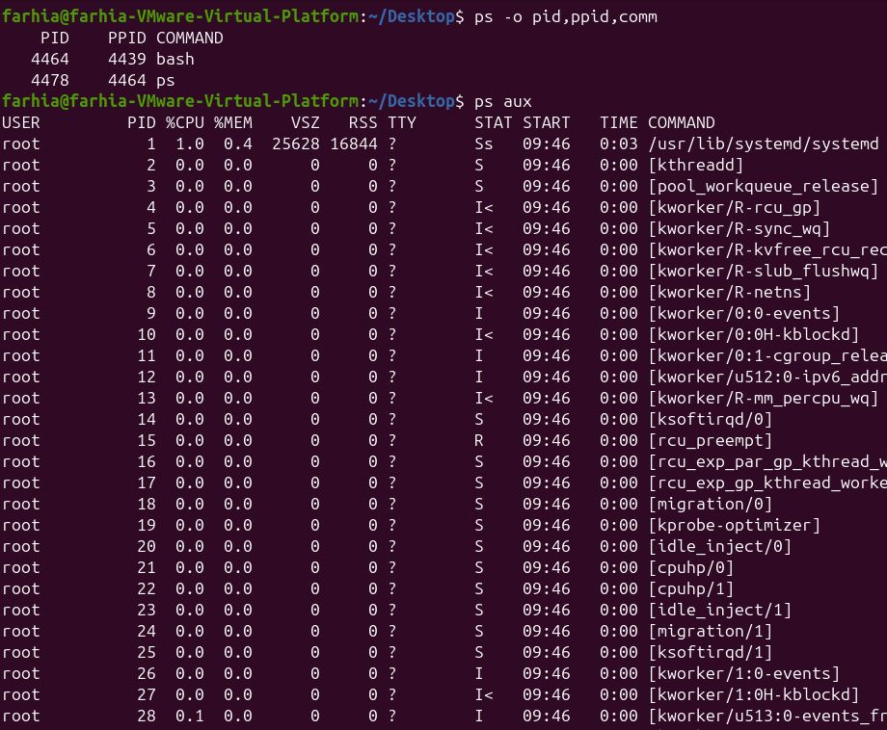
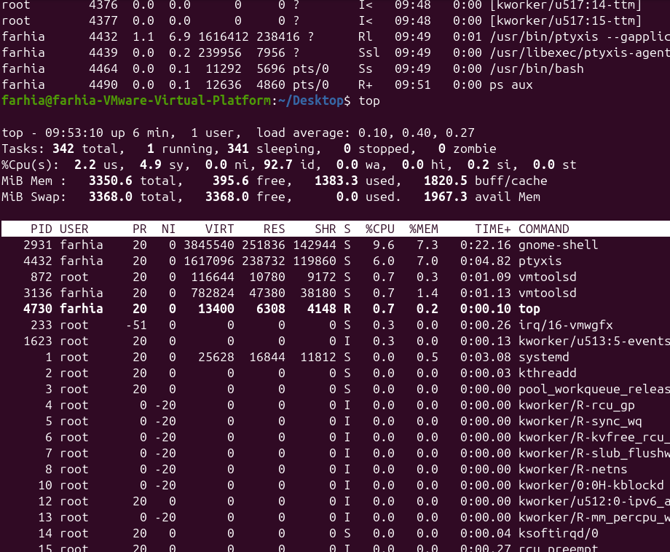

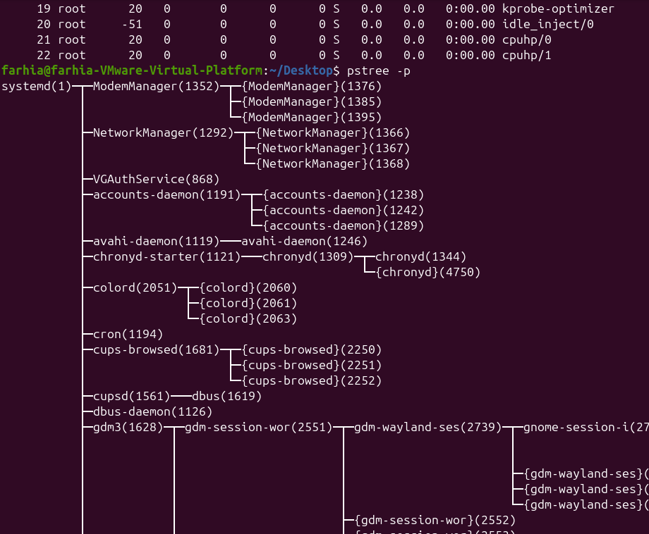

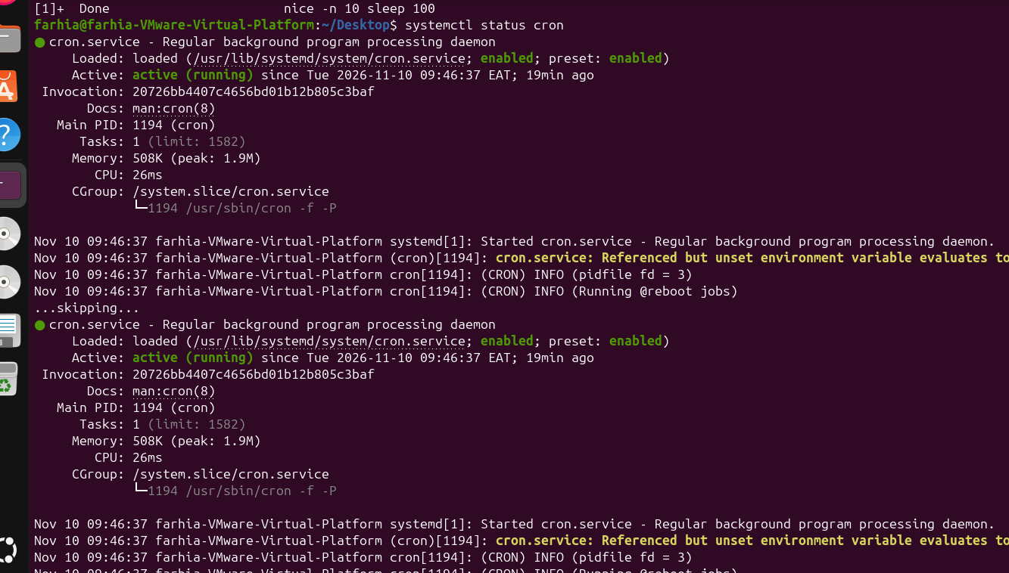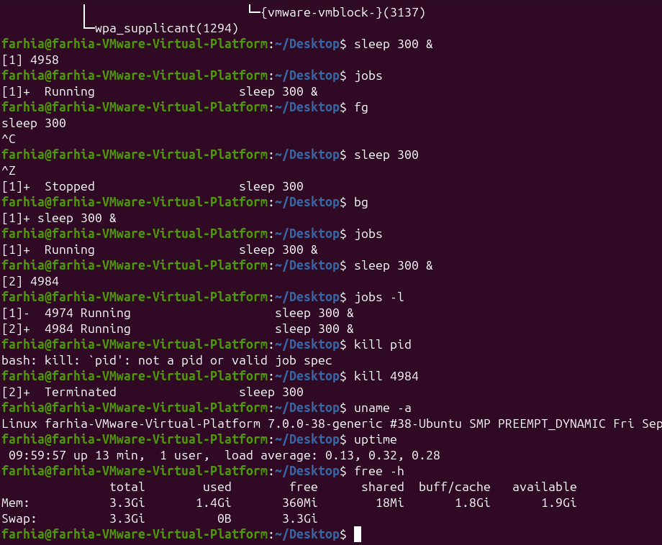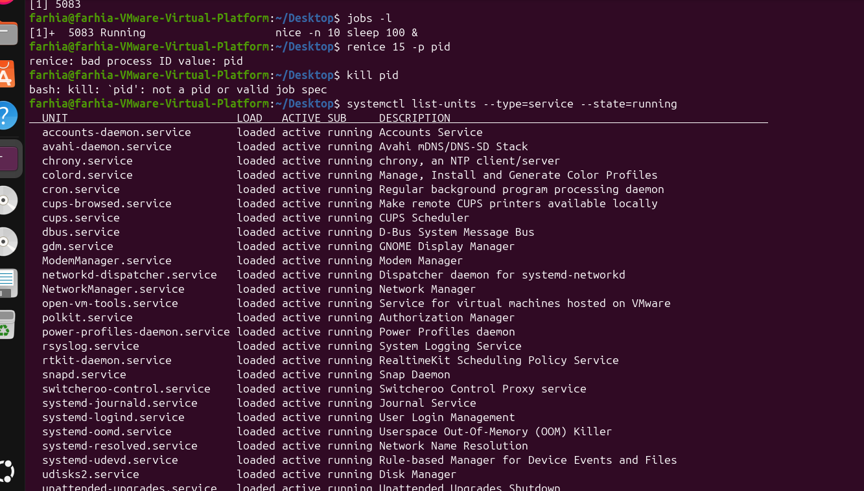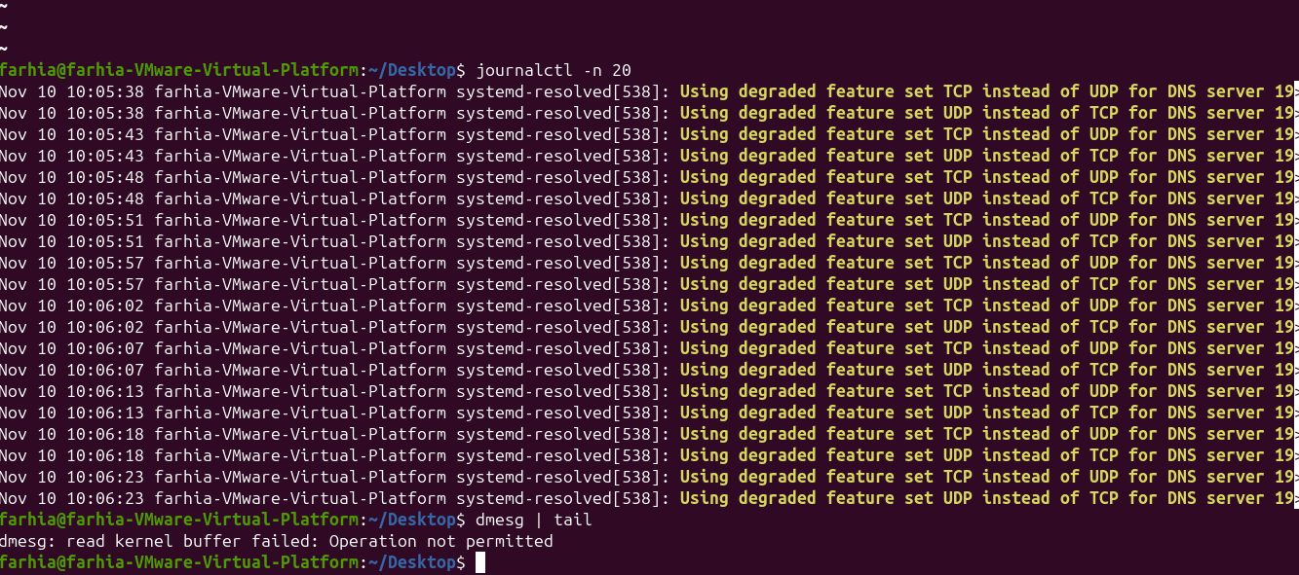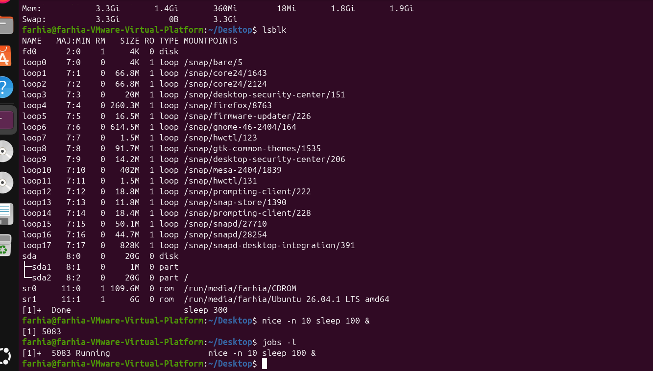

Exam revision: questions and answers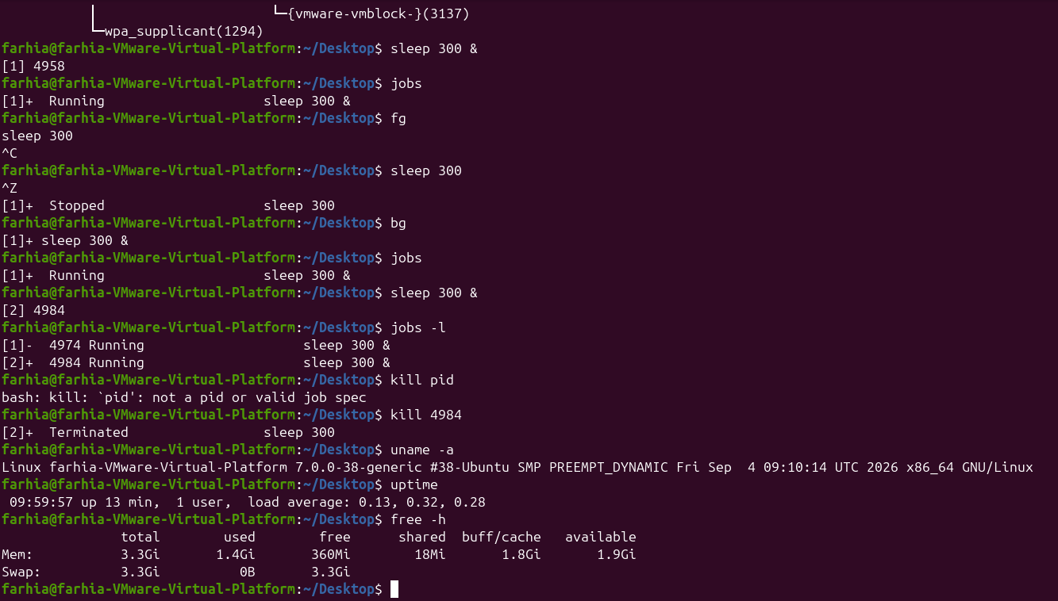
Q: What is a process?
A: A process is a program that is currently running.
Q: What is PID?
A: Process ID: the unique number assigned to a running process.
Q: What does ps show?
A: It displays information about running processes.
Q: What does Ctrl+C do?
A: It interrupts the foreground process.
Q: What does jobs do?
A: It lists jobs started from the current shell.
Q: What is the default signal sent by kill PID?
A: SIGTERM (signal 15).
Q: What does uptime show?
A: How long the system has been running and its load average.
Q: What is systemctl used for?
A: It manages and checks systemd services.
Q: What does journalctl do?
A: It reads systemd journal logs.

FINAL CHECKLIST — SCREENSHOTS, GITHUB, AND SUBMISSION

Before saving the Word document
- Fill in your name, student ID, class, lecturer, and submission date.
- Run the practical commands in your own Ubuntu VM.
- Insert your own terminal screenshots in every chapter's screenshot section.
- Make sure screenshots are readable and show the command and result.
- Check spelling, headings, and page layout.
- Save the final file with a clear name, for example: Linux_Chapters_1-4_Assignment.docx.

GitHub upload checklist
- Sign in to your GitHub account.
- Open the repository where you want to submit the Linux assignment, or create a new repository if your lecturer allows it.
- Choose Add file, then Upload files.
- Upload the completed Word document. You may also upload your screenshot image files if required.
- Write a short commit message, for example: Add Linux Chapters 1-4 assignment.
- Select Commit changes and wait for the upload to finish.
- Open the repository and check that the Word document and screenshots are visible.
- Copy the repository link and submit it through McLink if that is what your lecturer requested.

Suggested README text for GitHub
# Principles of Linux Operating Systems — Chapters 1–4
This repository contains my Linux course assignment for Chapters 1–4.
- Chapter 1: Introduction to Linux and Ubuntu
- Chapter 2: Linux System Architecture, Command Line, and File Management
- Chapter 3: Text Processing, Searching, Archiving, and Editors
- Chapter 4: Process, Service, and System Management
The assignment includes command explanations, practical examples, and my Ubuntu terminal screenshots.

Final note
This document covers Chapters 1–4, based on the four chapter materials available for this assignment. The screenshot spaces are intentionally left for your own practical evidence. Review your lecturer's exact submission instructions before uploading.

